Table of Contents
Benefits of Data Analysis in Retail Organisation 3
Introduction 3
Data Collection and Description 3
Sample Data used 3
Data Preparation and Visualisation in Power BI 4
Data Visualisation: 4
Business Impact Evaluation 5
Potential Sources of Error and Bias 6
Conclusion 6
Hypothesis Testing 6
Introduction 6
Hypothesis Formulation 6
Pearson’s Correlation Coefficient Statistical Test 7
Performing the Hypothesis Test with the SciPy package in Python 7
Interpretation and Discussion of the Result 8
Hypothesis Overview: 8
Decision on Hypothesis 8
Implications for Organizational Strategy 9
Visual Representation of the Hypothesis 9
Scatter Plot Overview 9
Data Distribution: 10
Regression Line Slope (~3714.51): 10
Visual vs. Statistical Findings 10
Statistical Confirmation: 10
Conclusion 10
Scalable Data Infrastructure Design for Retail Organisations 11
Type of Data Collected in a Retail Organisation and Reason 11
Proposed Data Infrastructure Architecture 12
Illustration of the Architecture of theSystem 12
Rationale ofKey Technologies 12
Storage and Analysis Approach 13
Storage Strategy 13
Conclusion 14
Legal and Ethical Considerations For The Proposed System 14
Legal and Ethical Considerations ofData 14
Ethical Considerations 15
Reference Codes & Frameworks: 15
Ethical andLegal Implications for the Suggested System 15
A Leading Example for DataSensitivity and Classification 15
Limitation ofdata and purpose 15
Vendor Compliance 16
Looking Ahead: Machine Learning &A.I. Risks 16
Bias and Discrimination 16
Not Transparent /Explainable 16
Automated Decision-Making 16
Consent to Artificial Intelligence Behavioural Tracking 17
Global Governance Complexity 17
Conclusion 17

Benefits of Data Analysis in Retail Organisation

Introduction
Retail Companies use data analytics and visualisation to gain business insights into customer behaviour, product categories, stock position and sales trends. This, in turn, leads to data-driven decision-making by senior executives. Due to GDPR, I will be using PowerBI dashboard to visualise Coca-Cola sales data obtained from a public source to leverage similar trends of data that will be used by a retail company.

Data Collection and Description
In one of the retail groups I have worked in, data is collected from the tills system (Enactor), websites, mobile apps, warehouse management systems and Social Media Ads platforms. This information is stored in Oracle and SQL database. The data is then ingested into BigQuery while Fivetran is used for integration. Power BI and Looker are used for data visualisation, but in this report I will focus on Power BI for visualisation.
Several datasets are collected, including:
- Returns data set: This is to understand the return data associated with the sales and the overall return rate by product.
- Discount dataset: This gives the overall discount for a given period. Which products or product categories have the highest and lowest discount rates?
- Stock position data: This is used to find out the position and average cost of stock in the warehouse/store/transit. This data is used to answer questions like how the stock quantity for a particular product changes over time and the average stock quantity for a particular product category.
- Sales dataset: Containing all till transaction line-level data in multiple currencies from Fraser group stores. This is used for reporting against product hierarchy, store location, product gender, and supplier.

Sample Data used
For this report, I will use Coca-Cola sales data available for public download to demonstrate sales data visualization in Power BI. This dataset includes retail, retail ID, Invoice Date, Region, State, city, beverage Brand, price per Unit, Unit Sold, Total Sales, Operating profit, and Operating Margin columns.
Coca-Cola data link https://drive.google.com/drive/folders/1RXmH4GTESMr0qEO8HoFBv50OE0PGFSK_

Data Preparation and Visualisation in Power BI
ETL plays a vital role in getting data into BigQuery and making it available for analysis in Power BI.
- Extraction: In this step, data is ingested from various sources, including Oracle and SQL Database both on-prem and cloud, APIs, spreadsheets
- Transformation/Data Modelling: Sales values are converted into a common currency and product categories are standardised. Missing values in customer demographics are imputed, duplicate transactions are removed, and inconsistent date formats are standardised.
- Loading: The data is then loaded into Power BI where the data is analysed and visualised. Power Query is used to perform further data cleaning and transformation. the relationship between different data tables and sources is built in the model view of Power BI. DAX is used to build measurements and calculations.
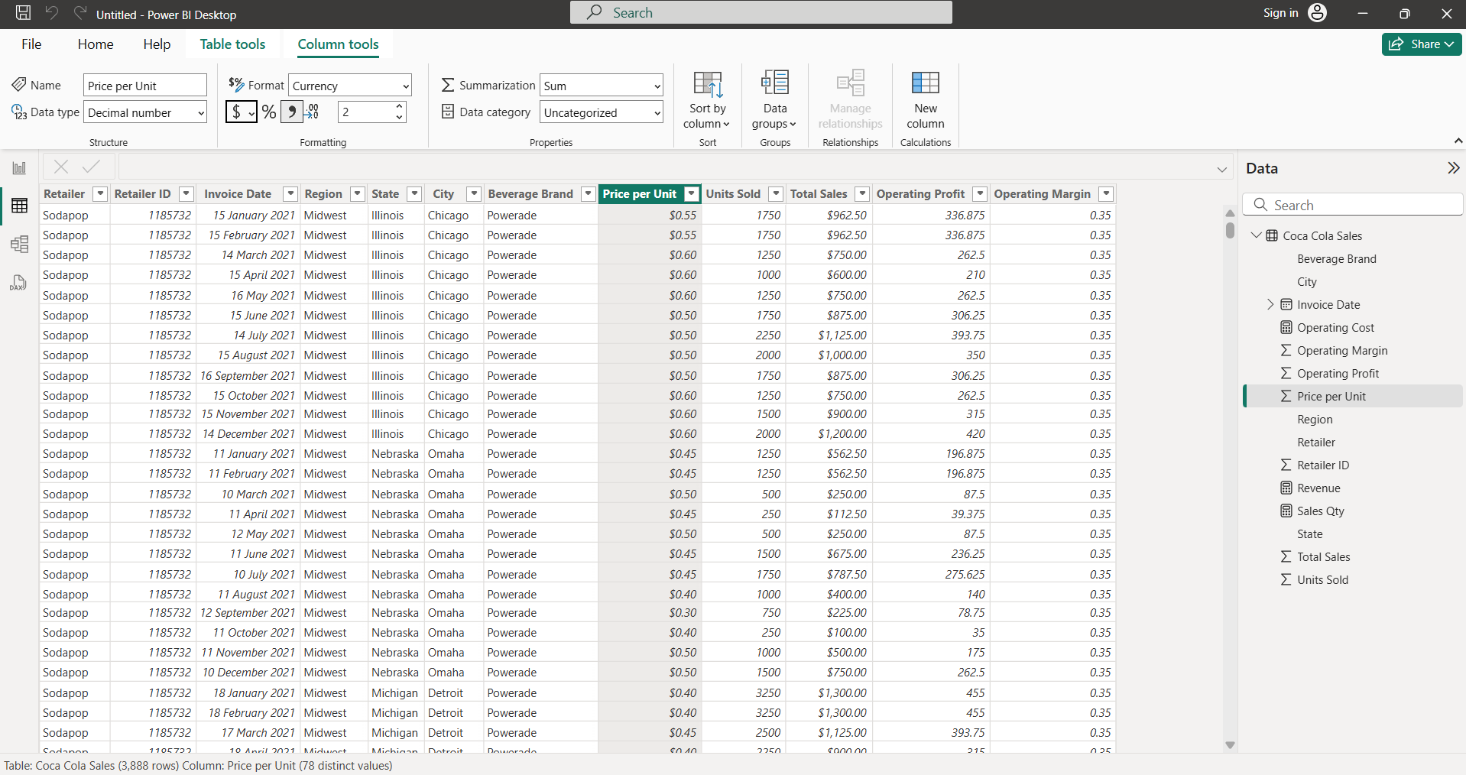
Figure 1. Table view of loaded Coca-Cola sales data

Data Visualisation:
In the report view, I used charts, graphs, and maps to build visuals that demonstrate relationships between data used to make data-driven decisions.
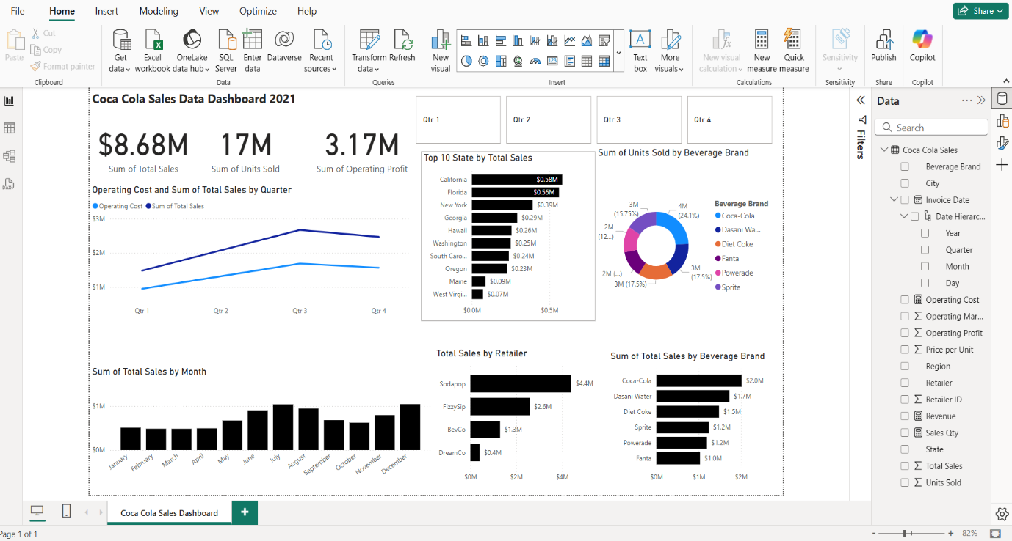
Figure 2. Coca-Cola sales data Power BI dashboard.

Business Impact Evaluation
Visualising data using Power BI has multiple benefits for the business. I will analyse the Data dashboard in Figure 2 to show data trends and how they can be used to drive data-driven decisions.
- Sales Performance analysis: This gives real-time insights into sales performance to enhance forecasting accuracy.
- A stacked column chart showing the sum of total sales by month, with July and December being the months with the highest sales, which can be referred to as the peak period.
- Stacked bar chart showing the 10 states by total sales, with California and Florida as the best-performing state in terms of sales
- Profitability Analysis
- Line chart showing operating cost and total sales by quarter
- Beverage Brand and Retailer Sales Breakdown:
Identifies top-performing brands and retailers, supporting revenue optimization.
- A stacked bar chart shows the sum of total sales by beverage brand, with Coca-Cola as the top-performing brand.
- Stacked bar chart of the sum of total sales by retailer, with Sodapop as the highest retailer

Potential Sources of Error and Bias
Biases and errors that can be present in the dataset include:
- Missing Data and Incomplete Records
  - There might be the presence of missing or incomplete data for key variables that can distort overall trends. Incomplete records from retailers or regions can cause the aggregate measures to give an untrue picture of performance
- Outlier Influence
- Very high values in the total sales or operating profit can skew the overall analysis. This can overly affect trends and averages, which can result in misinterpretation of typical performance
- Duplicate Values
- The presence of duplicate values can affect the reading of the dataset

Conclusion
This artefact shows the benefit of integrating data analytics in retail companies' sales data reading. Power BI dashboard provides actionable insights into sales performance and customer behaviour. Future enhancements could include machine learning for predicting future sales trends and AI-driven recommendations for dynamic pricing strategies.

Hypothesis Testing

Introduction
Using the Coca-Cola sales dataset to answer one critical business question: Does a higher price per unit result in fewer units sold? Addressing this question can provide insights into price elasticity, helping the organization balance revenue maximization with volume sales.

Hypothesis Formulation
To explore this question, I began by clearly stating the hypotheses:
Null Hypothesis (H₀): There is no relationship between Price per Unit and Units Sold (i.e., the correlation coefficient, ρ, equals zero).
H₀: ρ = 0
Alternative Hypothesis (H₁): There is a negative relationship between Price per Unit and Units Sold, meaning that as the price increases, the units sold decrease (i.e., ρ < 0).
H₁: ρ < 0
By formulating this hypothesis, I aim to determine whether the data provides sufficient evidence to conclude that pricing impacts sales volume in a statistically significant way.

Pearson’s Correlation Coefficient Statistical Test
I have chosen Pearson’s Correlation Coefficient to determine the strength and direction of the linear relationship between Price per Unit and Units Sold, both of which are continuous variables. Key reasons for this choice include:
Continuous Data Suitability: Ideal for measuring linear relationships between two continuous variables.
Interpretability: Provides a correlation coefficient (r) and p-value for assessing relationship significance and direction.
Assumption Validity: Works best under the assumption of normal distribution and linearity, making it simpler than non-parametric methods like Spearman’s rank correlation.

Performing the Hypothesis Test with the SciPy package in Python
I perform the Pearson correlation test using Python's SciPy package. The Screenshot below shows a sample code snippet that demonstrates this process.
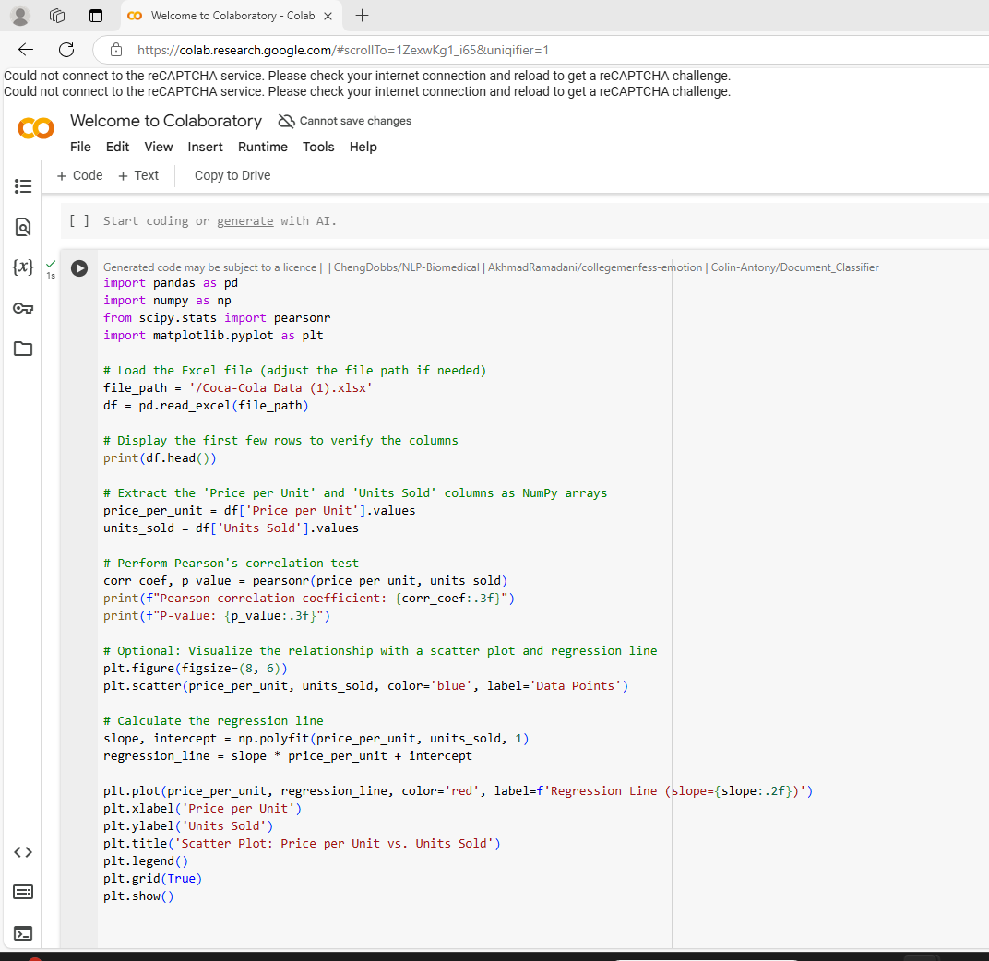
Fig 1: The Screenshot of sample code snippet for Pearson correlation coefficient.

Interpretation and Discussion of the Result
The Pearson correlation coefficient of 0.247 indicates that there is a weak positive linear relationship between Price per Unit and Units Sold. In practical terms, this suggests that, in this data set, as the price per unit increases the units sold tend to increase slightly. However, the effect is weak, given the magnitude of the correlation.
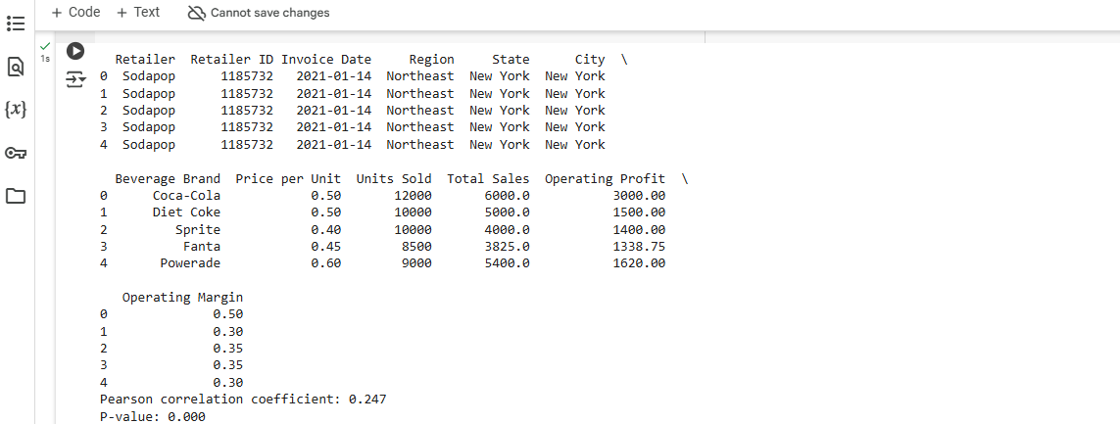Fig 2: Screenshot Showing the Pearson correlation coefficient.
The associated p-value of 0.000 (i.e., p < 0.001) tells us that this relationship is statistically significant. In other words, there is a very low probability that this observed correlation is due to random chance.

Hypothesis Overview:
Null Hypothesis (H₀): No negative relationship between price and units sold.
Alternative Hypothesis (H₁): A negative relationship exists.
The Pearson correlation test confirmed a positive correlation coefficient (0.247) with a significant p-value (0.000), contradicting initial hypotheses.

Decision on Hypothesis
- Outcome:
The null hypothesis is rejected because the alternative hypothesis predicted a negative correlation, but the observed correlation is positive (0.247). There is no evidence to support that an increase in price per unit leads to a decrease in units sold.
- Interpretation:
The statistically significant result (p < 0.001) confirms that there is a real relationship between Price per Unit and Units Sold in the dataset; however, the direction of this relationship is contrary to our initial expectation. Instead of a negative relationship, the data reveal a weak but significant positive relationship, indicating that higher prices are slightly associated with higher sales volumes.

Implications for Organizational Strategy
This finding has key strategic implications:
- Pricing Strategies: Higher prices may not hurt sales; they could boost units sold due to perceived quality.
- Segmentation Analysis: The positive relationship might differ across product lines, requiring analysis by brand, region, or demographics.
- Branding Strategies: If higher prices lead to increased sales, the company should consider premium pricing and enhancing brand value.
- Further Investigation: The weak correlation (0.247) indicates that other factors, like marketing and seasonal trends, must be analysed to fully understand sales dynamics.

Visual Representation of the Hypothesis

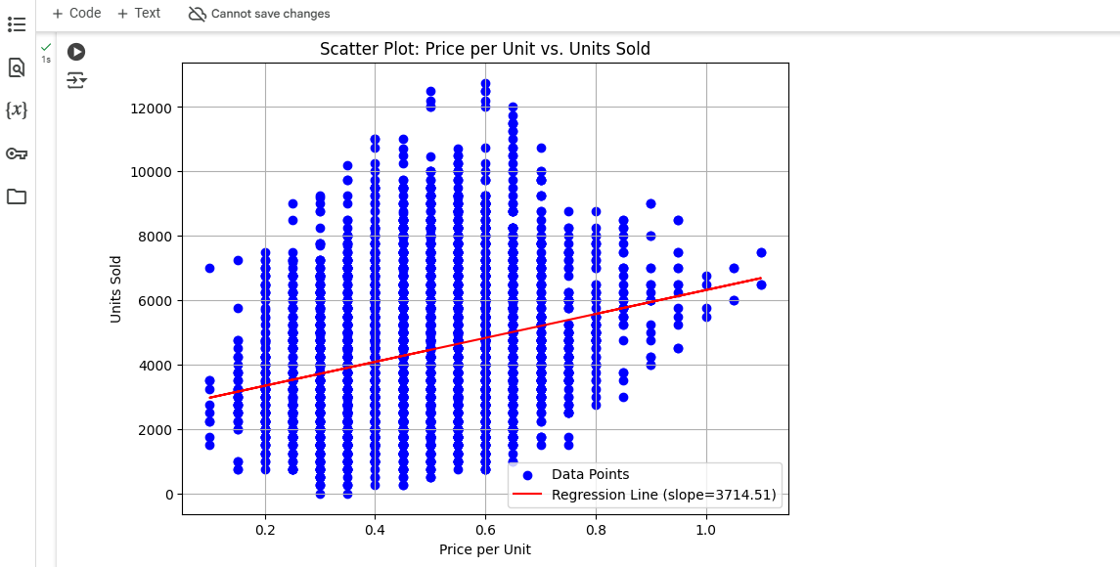
Fig 3: Screenshot of Scatter Plot: Price per Unit vs Unit Sold

Scatter Plot Overview
Axes:
- X-Axis (Price per Unit): Ranges roughly from 0.2 to 0.8 in the plotted data.
- Y-Axis (Units Sold): Ranges up to about 12,000 or more.

Data Distribution:
- The blue points are widely scattered, indicating considerable variability in units sold for a given price.
- However, the red regression line shows a slight upward slope.

Regression Line Slope (~3714.51):
- The slope tells us that, on average, for every 1-unit increase in Price per Unit (e.g., from $0.50 to $1.50), Units Sold would increase by approximately 3,714 units—according to this linear model.
- Given the actual scale of Price per Unit (often cents rather than whole dollars), real-world changes in price are typically much smaller, so the predicted change in units sold would be proportionally less.

Visual vs. Statistical Findings
Visual Confirmation:
- The scatter plot shows a wide dispersion of data points, but the regression line does tilt upward, confirming the positive correlation.
- Many data points lie far from the line, reflecting the weak strength of the relationship. Still, the overall trend aligns with the statistical finding.

Statistical Confirmation:
- The correlation coefficient and p-value quantify what the scatter plot suggests: a weak but statistically significant positive relationship.
The scatter plot indicates a mild upward trend, and the Pearson correlation analysis mathematically confirms that there is indeed a positive (but not very strong) relationship between Price per Unit and Units Sold.

Conclusion
A Pearson correlation analysis of the Price per Unit and Units Sold columns in the dataset revealed a weak but statistically significant positive relationship (r ≈ 0.247, p < 0.001). Visually, the scatter plot and regression line confirm this upward trend. Although common belief might suggest higher prices reduce sales, this particular dataset shows a slight increase in units sold as prices rise, possibly due to factors like premium branding or perceived quality. However, given the correlation’s weakness, other variables (e.g., region, product type, promotions) also likely influence sales volume. This insight shows the benefit of further segmentation and analysis before making strategic pricing decisions.

Scalable Data Infrastructure Design for Retail Organisations
In the context of a retail organisation with multiple fascias running different clothing brands, creating a robust data infrastructure is key to driving informed decision making, enable omnichannel commerce and support personalisation at scale. Using a data warehouse approach, this essay describes a data structure which can accommodate both traditional and big data types. Additionally, it provides the rationale behind collecting data, details the proposed architecture (Google BigQuery and by Fivetran), and describes how data will be stored and used for analytics.

Type of Data Collected in a Retail Organisation and Reason
A retail ecosystem creates a wide range of structured and semi-structured data that needs to be captured and processed to extract useful insights. Here are the primary data domains and why they matter:
Sales Data
Sales data is captured at tills and online checkouts, providing granular insights into transaction volumes, customer preferences, seasonality and pricing effectiveness.
Sales Discount Data
Discounting by brand and region is used to evaluate the effect of marketing strategies and the risk of margin erosion.
Returns Data
Tracking returns provides quality control, the ability to evaluate customer satisfaction, and a means to identify potential fraud or operational inefficiencies.
Stock Position Data
Real-time inventory levels are necessary for supply chain efficiency, preventing stockouts, and allowing for accurate fulfillment.
Stock Movement Data
The details for shipping, transfers between stores, replenishment, shrinkage, etc., this data aids optimisation in logistics, inventory planning, etc.
Ads and Campaign Data
ROI and attribution: Digital marketing spend and ad performance metrics (impressions, click-throughs, etc.) can be used to measure ROI and support attribution models.
Customer Segment Data
Segmentation (high-value, churn-risk, new, etc.) facilitates tailored marketing and loyalty programs.
Emarsys Data
Emarsys data gives visibility into customer engagement, campaign performance, and CRM performance cross-channel.
All these data types play their roles in driving operational efficiency, improving customer experience and enabling strategic planning.

Proposed Data Infrastructure Architecture
Since it was necessary to integrate data from various systems and to allow both real-time and batch processing, a centralised data warehouse architecture was adopted, which was deployed on Google BigQuery, which is a highly scalable and fully managed cloud data warehouse.

Illustration of the Architecture of the System
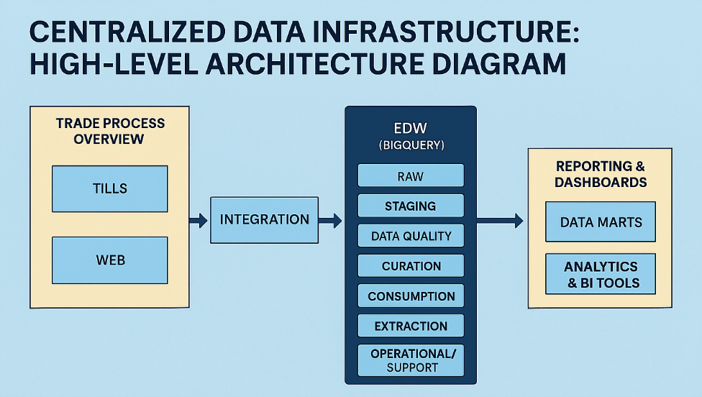
Fig 4: Centralised Data Infrastructure: High-Level Architecture Diagram.

Rationale of Key Technologies
Fivetran (Integration Layer):
Fivetran is attractive because of its easy-to-use, low-maintenance, and strong, ready-to-use connectors to ERPs, CRMs, marketing and e-commerce systems. It enables continuous sync and schema evolution, which is crucial for a retail space where platforms change relatively frequently.
Google BigQuery (data warehouse):
Pragmatic Institute chose BigQuery because of its serverless architecture, elasticity, real-time analytics capabilities, and native integration with Google Cloud and Looker. It is able to perform SQL-based query can handle petabytes of data generated by retail and e-commerce operations.
Layered EDW Architecture:
Data Layer: Raw Layer, stores unmodified data ingested from source systems.
Staging Layer: A temporary holding space for transformation and cleansing.
Data Quality Layer: Completeness, Duplicates and Referential Integrity validations.
Curation Layer: Data is normalized and enriched for analytical purposes.
Consumption Layer: Arranged by subject areas (e.g., sales, stock).
XLayer: It is meant for exporting the data into different systems.
Operational/Support Layer — For monitoring the runs of pipelines, lineage, and metadata.
It also helps with data governance, versioning, and parallel development of new pipelines with lesser impact to production.

Storage and Analysis Approach

Storage Strategy
Raw data and processed data are all stored in Google BigQuery, which decouples storage from compute, providing cost efficiency and scalability. Optimized performance and cost (using time-partitioned and clustered tables) Compliance and governance are supported through schema versioning and metadata tagging (e.g., flags for GDPR, sensitivity levels).

Data Harnessing for Analysis
Exploratory: Data Analysis Analysts query data in BigQuery using SQL or through first exploration tools like Looker or Tableau.
Operational Reporting: Dashboards displaying live KPIs such as daily sales, return rate, or campaign ROI are provided from the curated and consumption layers.
Machine Learning & AI: The data is channeled into Google Vertex AI or BigQuery ML for predictive modeling (for example, demand/supply estimation, customer churn estimation).
Segmentation & Personalization: Emarsys and internal models leverage curated customer data to personalize emails, in-app offers and store-promotions.

Conclusion
That cloud-native, centralized data infrastructure is built to bring together traditional and big data in a complex retail organisation. Fivetran, BigQuery, Agility, Scalability, Compliance The execution of the solution delivers a logical layer structure over the data warehouse, giving the business the ability to automate their processes as much as possible while including governance as part of their control with their business processes, allowing them the ability to give fast, in-demand analytics, deep forward and backward predictive analytics, and enhanced customer experience through their interactions and all very key to the successful retail environment.

Legal and Ethical Considerations For The Proposed System
In a rapidly data-oriented society, when legal and ethical considerations are not just a box to tick but are crucial for securing customer confidence, preventing reputational harm, and driving sustainable system building. As the system developed, it was recognised that involvement of parts of the algorithm at some point in the future would need to adhere to the many international practices of a multinational organisation that operates in the UK, EU, US and Africa/ and other geographies.

Legal and Ethical Considerations of Data
Legal and ethical Duties vary by jurisdiction but some core principles hold across the board:

Legal Obligations
Regulation around Data Protection:
- UK GDPR and Data Protection Act 2018: Clear lawful bases for data collection, transparency, data minimization and data subject rights (e.g., access, rectification, erasure) are required.
- EU GDPR: Closely aligned with UK GDPR but extends scope via the extraterritorial provisions.
- US (CCPA, CPRA): Focus is on consumer data rights, giving individuals the right to opt out of data being shared or sold.
- Data Laws in Africa: Several countries (Nigeria, Kenya, etc.) are drafting and adopting data protection laws (eg. Nigeria Data Protection Regulation — NDPR) based on GDPR inspiration.
- Cross-border Data Transfer: Adequate safeguards must be in place before transferring any personal data to countries outside the EU, particularly from the EU to the US or Africa (e.g. Standard Contractual Clauses or Binding Corporate Rules).
- Sectoral Regulations: Relevant parts of marketing and consumer protection laws (for instance, the PECR in the UK) govern the further usage of customer data in context of promotion or other campaigns.

Ethical Considerations
• Fairness and Transparency: The customers should know what data is being collected, how it is being used and for how long it is retained.
• Informed Consent: For sensitive data (e.g., behavioral tracking), users need to actively opt in with clear info.
• Ownership and control of data: Customers should own and control their data, including the right to withdraw consent.
• No Harm: Beyond avoiding any security breaches or unauthorised use of customer data, ethical responsibility must also be taken when using technology, ruling out any discriminatory outcomes.

Reference Codes & Frameworks:
• OECD Privacy Principles
• ACM Code of Ethics
• Guidance from the UK Information Commissioner’s Office (ICO)
• IEEE Global Initiative on Ethics of Autonomous and Intelligent Systems

Ethical and Legal Implications for the Suggested System
Legal and Ethical Risks Given the Proposed Centralized Data Warehouse (Google BigQuery) with Fivetran Integration.

A Leading Example for Data Sensitivity and Classification
The PII, including purchase history, segment data and engagement metrics by Emarsys will be processed by the system. This type of data requires:
- Tagging of PII and Data Cataloguing
- Access control based on roles (RBAC)
- Both at-rest and in-transit encryption

Limitation of data and purpose
Append only the data needed for an operational, analytical, or personalization purpose. For instance:
Store email addresses only where analytics of engagement is required (not for each customer transaction).
Create a system where marketing opt-in data is segregated from transactional systems to prevent any abuse.
The right to object to data subject rights implementation
The architecture should contain APIs or processes to fulfil the following requests:
Access to, or portability of, data (e.g., the ability to download purchase history)
Eraser (“the right to be forgotten”)
Data Hygiene These should collect accurate and up-to-date information only; inaccurate data needs correcting. A centralized data warehouse and extraction workflows should be processed to avoid fragmentation.

Vendor Compliance
Monitoring and vetting of both Fivetran and Google BigQuery for use with high-risk data must include:
- ISO 27001, SOC 2 Type II certified
- Data residency requirements support
- International Data Transfer Mechanisms(e.g., EU-U.S. S. Data Privacy Framework)

Looking Ahead: Machine Learning & A.I. Risks
As the system matures to enable predictive analytics or customer segmentation by means of ML, more legal and ethical challenges arise:

Bias and Discrimination
Algorithms trained on past sales or returns data may unintentionally learn and amplify biases (for example, assumptions about gendered purchasing behavior or regional return trends).
Mitigation: Fairness-aware ML techniques, periodic model audits, and explainability tools (SHAP, LIME) to identify biased feature importance.

Not Transparent / Explainable
Customers might get discount offerings or suggestions based upon opaque models.
Mitigation: Make sure models that are used in customer-facing systems are interpretable and decisions can be explained in layman’s terms.

Automated Decision-Making
Profiling or price personalization may activate Article 22 of GDPR (automated decisions without human intervention).
Mitigation: Human-in-the-loop for high-criticality decisions; opt-out mechanisms

Consent to Artificial Intelligence Behavioural Tracking
Cookies or email/web behaviour tracking is traditionally how campaign platforms, like Emarsys, operate.
Mitigation: Cookie consent (eg, EU ePrivacy Directive) must be followed, and tracking should be limited to those users who have actively consented.

Global Governance Complexity
Data ethics is subjective and varies from one point of the globe to another; some things we might be doing here may not be acceptable in other regions.
Mitigation: Establish a centralised data ethics board, with regional representation, and apply a “highest standard” principle for international systems.

Conclusion
The legal and ethical considerations for a global retail organisation in designing and evolving a data infrastructure are significant, but manageable. This process helps in establishing robust and responsible data ecosystem following the principles of data protection through the incorporation of data protection principle in system design (privacy by design and by default), transparent ML practices and regular auditing for any jurisdiction compliance gaps. This not only reduces legal risk, it develops the trust of customers and integrity in markets.

